College Tuition

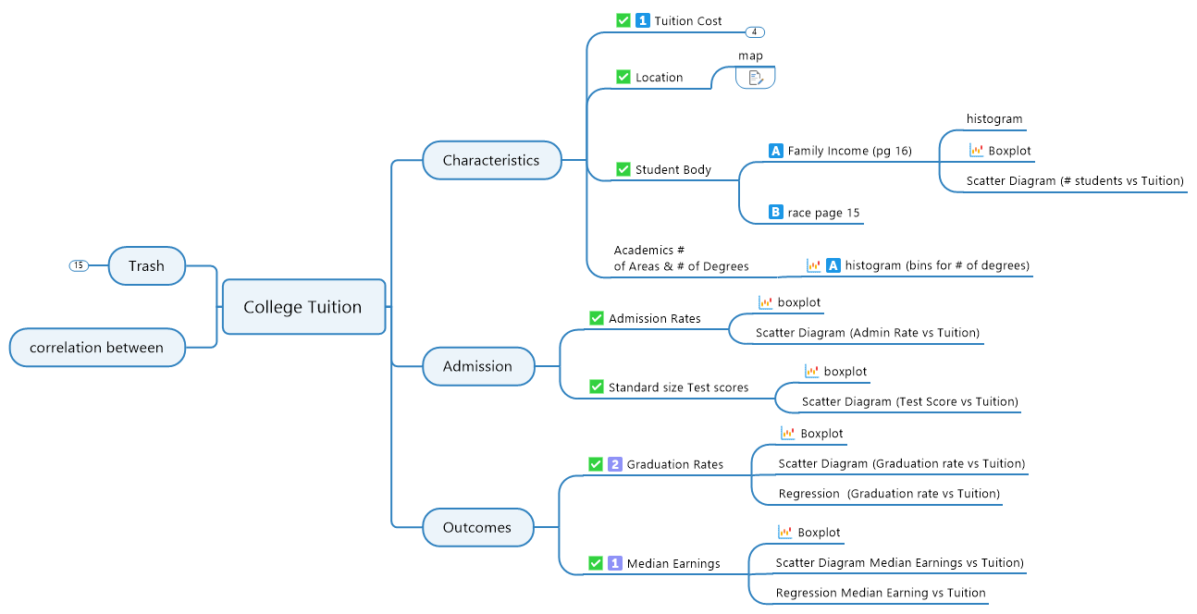

1. Characteristics 2

1.1. Tuition Cost 2

1.1.1. histogram 2

1.1.2. boxplot 2

· Histogram of Q1 3

1.1.3. Scatter Diagrams ( x vs Tuition) 3

1.2. Location 4

1.2.1. map 4

1.3. Student Body 4

1.3.1. Family Income (pg 16) 4

· histogram 4

· Boxplot 4

· Scatter Diagram (# students vs Tuition) 5

1.3.2. race page 15 5

1.4. Academics # of Areas & # of Degrees 5

1.4.1. histogram (bins for # of degrees) 5

2. Admission 5

2.1. Admission Rates 5

2.1.1. boxplot 5

2.1.2. Scatter Diagram (Admin Rate vs Tuition) 5

2.2. Standard size Test scores 5

2.2.1. boxplot 5

2.2.2. Scatter Diagram (Test Score vs Tuition) 5

3. Outcomes 5

3.1. Graduation Rates 5

3.1.1. Boxplot 5

3.1.2. Scatter Diagram (Graduation rate vs Tuition) 6

3.1.3. Regression (Graduation rate vs Tuition) 6

3.2. Median Earnings 6

3.2.1. Boxplot 6

3.2.2. Scatter Diagram Median Earnings vs Tuition) 6

3.2.3. Regression Median Earning vs Tuition 6

4. correlation between 6

5. Trash 6

5.1. Instructional expenditures per FTE student (INEXPFTE) 6

5.1.1. boxplot 6

5.2. Public/Private-Nonprofit/Private-for-Profit 6

5.2.1. Stacked Bar % 6

5.2.2. pie 6

5.3. "Cohort Default Rate" 7

5.3.1. Boxplot 7

5.4. College Life 7

5.4.1. pull in the population with in x mile of the college 7

5.5. Distance-Only 7

5.6. Highest Degree offered 7

5.7. Student Body 7

5.7.1. age 7

5.7.2. Gender 7

5.7.3. Student body size 7

1. Characteristics
   1. Tuition Cost

|  |  |
| --- | --- |
| Single Icons | CustomIcon-205142352; ["", "UDk6DAAAAAAAAAAAAAAAAA=="],  CustomIcon-548075254; ["", "9vaqIAAAAAAAAAAAAAAAAA=="] |

* + 1. histogram
    2. boxplot

|  |  |
| --- | --- |
| Single Icons | CustomIcon-361639122; ["", "0iyOFQAAAAAAAAAAAAAAAA=="] |

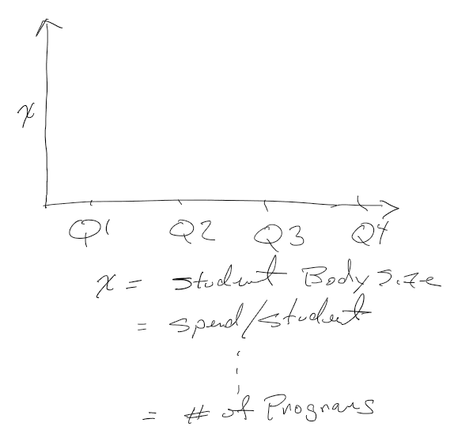

* + - * Histogram of Q1
    1. Scatter Diagrams ( x vs Tuition)

x =

* number of students
* # degrees offered

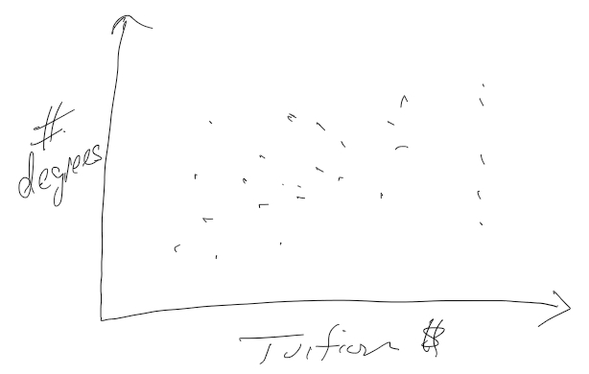

* 1. Location

|  |  |
| --- | --- |
| Single Icons | CustomIcon-205142352; ["", "UDk6DAAAAAAAAAAAAAAAAA=="] |

* + 1. map

Map with of USA with dots for each school location

Color by quartile.

Option - size = Tuition

* 1. Student Body

|  |  |
| --- | --- |
| Single Icons | CustomIcon-205142352; ["", "UDk6DAAAAAAAAAAAAAAAAA=="] |

* + 1. Family Income (pg 16)

|  |  |
| --- | --- |
| Single Icons | CustomIcon--1417696976; ["", "MKl/qwAAAAAAAAAAAAAAAA=="] |

* + - * histogram
      * Boxplot

|  |  |
| --- | --- |
| Single Icons | CustomIcon-361639122; ["", "0iyOFQAAAAAAAAAAAAAAAA=="] |

* + - * Scatter Diagram (# students vs Tuition)
    1. race page 15

|  |  |
| --- | --- |
| Single Icons | CustomIcon--1700959678; ["", "QmqdmgAAAAAAAAAAAAAAAA=="] |

* 1. Academics # of Areas & # of Degrees
     1. histogram (bins for # of degrees)

|  |  |
| --- | --- |
| Single Icons | CustomIcon-361639122; ["", "0iyOFQAAAAAAAAAAAAAAAA=="],  CustomIcon--1417696976; ["", "MKl/qwAAAAAAAAAAAAAAAA=="] |

1. Admission
   1. Admission Rates

|  |  |
| --- | --- |
| Single Icons | CustomIcon-205142352; ["", "UDk6DAAAAAAAAAAAAAAAAA=="] |

* + 1. boxplot

|  |  |
| --- | --- |
| Single Icons | CustomIcon-361639122; ["", "0iyOFQAAAAAAAAAAAAAAAA=="] |

* + 1. Scatter Diagram (Admin Rate vs Tuition)
  1. Standard size Test scores

|  |  |
| --- | --- |
| Single Icons | CustomIcon-205142352; ["", "UDk6DAAAAAAAAAAAAAAAAA=="] |

* + 1. boxplot

|  |  |
| --- | --- |
| Single Icons | CustomIcon-361639122; ["", "0iyOFQAAAAAAAAAAAAAAAA=="] |

* + 1. Scatter Diagram (Test Score vs Tuition)

1. Outcomes
   1. Graduation Rates

|  |  |
| --- | --- |
| Single Icons | CustomIcon-205142352; ["", "UDk6DAAAAAAAAAAAAAAAAA=="],  CustomIcon--1907045301; ["", "S8xUjgAAAAAAAAAAAAAAAA=="] |

* + 1. Boxplot

|  |  |
| --- | --- |
| Single Icons | CustomIcon-361639122; ["", "0iyOFQAAAAAAAAAAAAAAAA=="] |

* + 1. Scatter Diagram (Graduation rate vs Tuition)
    2. Regression (Graduation rate vs Tuition)
  1. Median Earnings

|  |  |
| --- | --- |
| Single Icons | CustomIcon-205142352; ["", "UDk6DAAAAAAAAAAAAAAAAA=="],  CustomIcon-1448251587; ["", "w5BSVgAAAAAAAAAAAAAAAA=="] |

* + 1. Boxplot

|  |  |
| --- | --- |
| Single Icons | CustomIcon-361639122; ["", "0iyOFQAAAAAAAAAAAAAAAA=="] |

* + 1. Scatter Diagram Median Earnings vs Tuition)
    2. Regression Median Earning vs Tuition

1. correlation between
2. Trash
   1. Instructional expenditures per FTE student (INEXPFTE)

|  |  |
| --- | --- |
| Single Icons | CustomIcon--418043955; ["", "zScV5wAAAAAAAAAAAAAAAA=="] |

* + 1. boxplot

|  |  |
| --- | --- |
| Single Icons | CustomIcon-361639122; ["", "0iyOFQAAAAAAAAAAAAAAAA=="] |

* 1. Public/Private-Nonprofit/Private-for-Profit
     1. Stacked Bar %
     2. pie

|  |  |
| --- | --- |
| Single Icons | CustomIcon-1253391552; ["", "wDy1SgAAAAAAAAAAAAAAAA=="] |

* 1. "Cohort Default Rate"

|  |  |
| --- | --- |
| Single Icons | CustomIcon--418043955; ["", "zScV5wAAAAAAAAAAAAAAAA=="] |

* + 1. Boxplot

|  |  |
| --- | --- |
| Single Icons | CustomIcon-361639122; ["", "0iyOFQAAAAAAAAAAAAAAAA=="] |

* 1. College Life
     1. pull in the population with in x mile of the college
  2. Distance-Only

|  |  |
| --- | --- |
| Single Icons | CustomIcon--418043955; ["", "zScV5wAAAAAAAAAAAAAAAA=="] |

* 1. Highest Degree offered
  2. Student Body

|  |  |
| --- | --- |
| Single Icons | CustomIcon-205142352; ["", "UDk6DAAAAAAAAAAAAAAAAA=="] |

* + 1. age
    2. Gender
    3. Student body size